# VISHWANATH SAVADATTI

Email- [vishusavadatti@gmail.com](mailto:vishusavadatti@gmail.com) Cellular: +918904887274

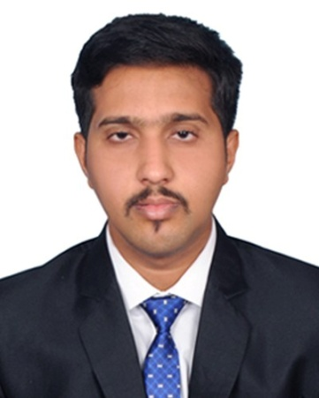

# CAREER OBJECTIVE

* To professionally serve the organization to the fullest individual capacity.
* To work in an organization where I can explore my ideas freely & contribute my Expertise, Diligence and Experience.

# INDUSTRIAL VISITS

* JSW Steel plant, Toranagallu, Bellary district.
* METCUT Toolings, Hubli.

# WORK EXPERIENCE

# Assistant Professor at K.L.E. Institute of Technology, Hubballi (Nov 2020- Present)

* **Lecturer at K.L.E’s Polytechnic, Bailhongal (July 2018- Oct 2020).**
* **4 months of Major Project Work at SPICER INDIA PVT LTD., JODALLI (Jan 2017- May 2017).**

**PROJECTS DURING COLLEGE:**

**I. During M.Tech**

# Major Project

**Title : WORK STANDARDIZATION OF THE DRIVE SHAFT COMPONENT “SLIP YOKE”**

**Brief Description:** The work standardization basically deals with standardizing the present work process to revised work process by reducing the cycle time and maintaining the process capability to the company standards. This work standardization helps in maintaining the company to meet the customer demand in time and with minimal rejection.

# Minor Project

**Title : STUDY OF FACTORS AFFECTING ELECTRONIC BUSINESS FOR SMALL AND MEDIUM ENTERPRISES (SME’S) IN HUBLI- DHARWAD REGION**

**Brief Description:** This study emphasis on identifying and explaining the various factors that influence the adoption of e-commerce by SME’s.

# II Projects During B.E MAJOR PROJECT

**Title: DESIGN AND FABRICATION OF VERTICAL AXIS WIND TURBINE.**

**Brief Description:** The project was done using the low density foam sheet and the results were high power generated using low wind speed.

# SOFTWARE CAPABILITIES:

* **AVIX**
* **ANSYS**
* **Python (PyCharm, Jupyter Notebook, Google Colab)**
* **Solidworks**
* **EdgeCam**

**EDUCATIONAL QUALIFICATION:**

|  |  |  |  |  |
| --- | --- | --- | --- | --- |
| **Qualification** | **Institution** | **Board/University** | **Year of Passing** | **Performance** |
| M.tech (Production Management) | K.L.E.T.U.(  Formerly known as BVBCET), HUBLI | K.L.E. Technological University, Hubli. | 2015-17 | 80% |
| B.E.  (Mechanical engg.) | K.L.E.I.T., HUBLI | Visveswaraiah Technological University, Belgaum. | 2013-14 | 65.1% |
| 2nd PUC | P C JABIN  SCIENCE COLLEGE,HUBLI | Pre-University Education | 2009-10 | 50.2% |
| S.S.L.C | DR G V JOSHI ENGLISH MEDIUM HIGH  SCHOOL,HUBLI | Karnataka Secondary Education Examination Board | 2007-08 | 85.28% |

# Publications

# Impact of injection timing (IT) on dual fuel engine fuelled with waste cooking oil methyl ester and producer gas S.S. Halewadimath a, N.R. Banapurmath V.S. Savadatti S

# Faculty Development Program

# “Introduction to Python Programming &amp; its Applications”19th – 23rd June 2023

# AICTE Quality Improvement program

# Presently Undergoing 6 months AICTE Quality improvement program at IIIT,Lucknow in Artificial and Machine Learning

**PERSONAL SKILLS:**

* Excellent verbal and written communication skills.
* Quick learner, hard-working, patient and sincere.
* Talented, exploratory, innovative individual and a team player.

# WORKSHOP/CONFERENCES/SEMINARS ATTENDED:

* 2 days CII conference at Bangalore for the topic on **ZED: ZERO DEFECT-ZERO EFFECT FOR “MAKE IN INDIA”** (DEC 2015)
* 1 day workshop at Bangalore for “**INDIAN ROOFTOP SOLAR PHOTOVOLTAIC LANDSCAPE- BUSINESS MODELS AND OPPURTUNITIES”**

# PERSONAL PROFILE

Name : Vishwanath Savadatti

Age : 33yrs

Nationality : Indian

Languages Known : English, Hindi and Kannada Hobbies : Reading, Watching Cricket Permanent Address : #235,JayaGanga Nilaya, Shivaganga layout, HUBLI- 580023